|  |  |  |
| --- | --- | --- |
| **LAB 321Assignment** | **Type:** | **LongAssignment** |
| **Code:** | **J3.L.P0022** |
| **LOC:** | **700** |
| **Slot(s):** | **15** |

**Title:** Melanie's Day Care

**Background**

### Do you want to startup with children care services!

Complete this assignment to know how to write a simple , beautiful website for your business

Reference site:<http://us-123daycare.simplesite.com/>

**Program Specifications**

Program a web site tointroduce your children day care services to your customers , detail functions of this website is described below

**Features:**

This website contains 4 main functions

* Function 1 : Home page : ( see PIC 01)
  + Display introduction entry and short description about : about me and contact
* Function 2 : About me Page ( PIC 02)
  + Print out sort information about author
* Function 3 : Photo album( PIC 03)
  + Display photo album of your kids
* Function 4: ( PIC 04)
  + Display contact information
  + Help user to submit they message

You do not need to write interface for admin control panel, you can add data manually (use SQL SERVER Management studio).

Note: All data must be load from database, not hard code in page.

***Expectation of User interface:***

Pic 01 : Home Page

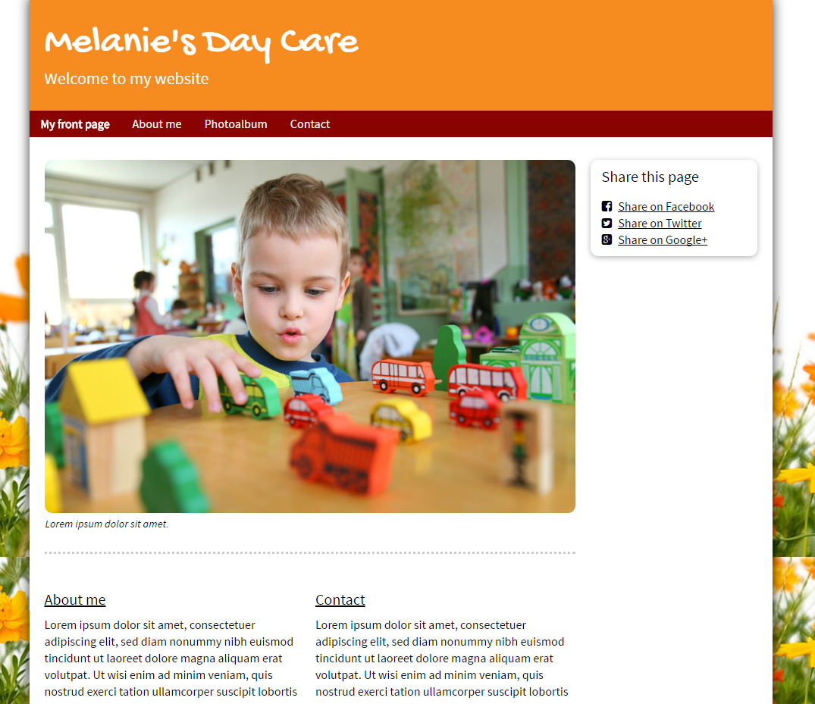

PIC 2 : About me page

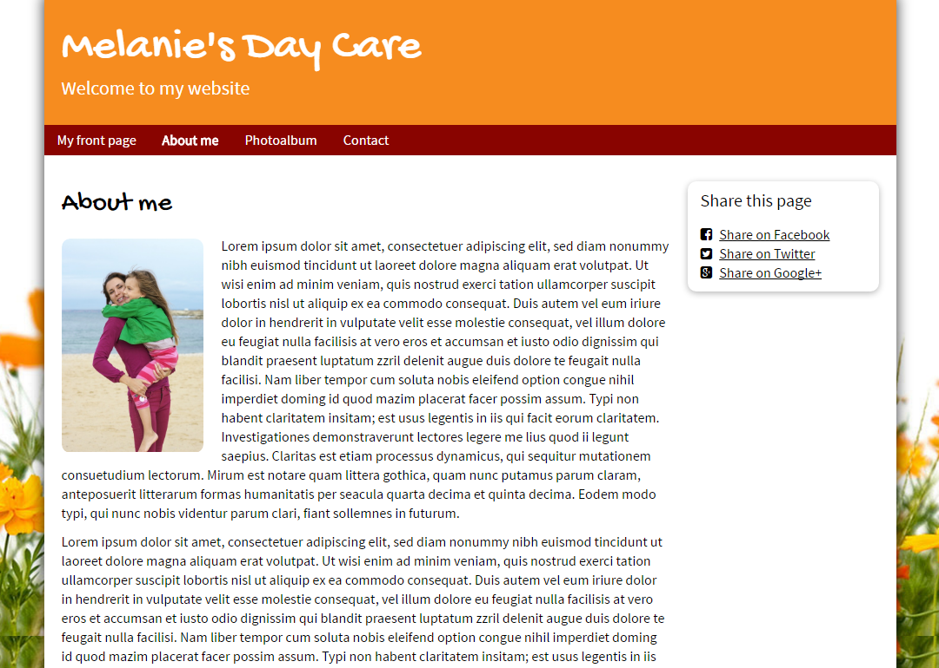

PIC 3 : PHOTO ALBUM

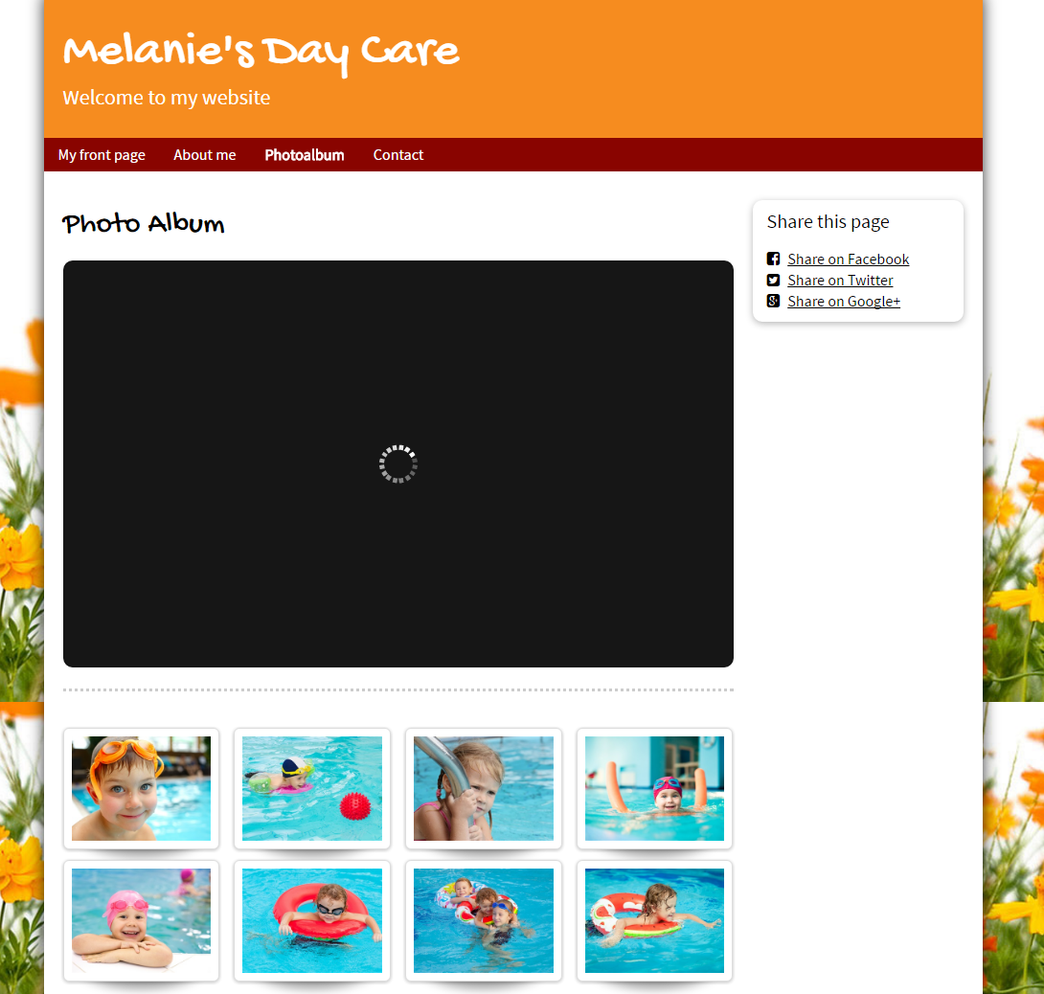

PIC 4 : Contact : allow user to submit message here

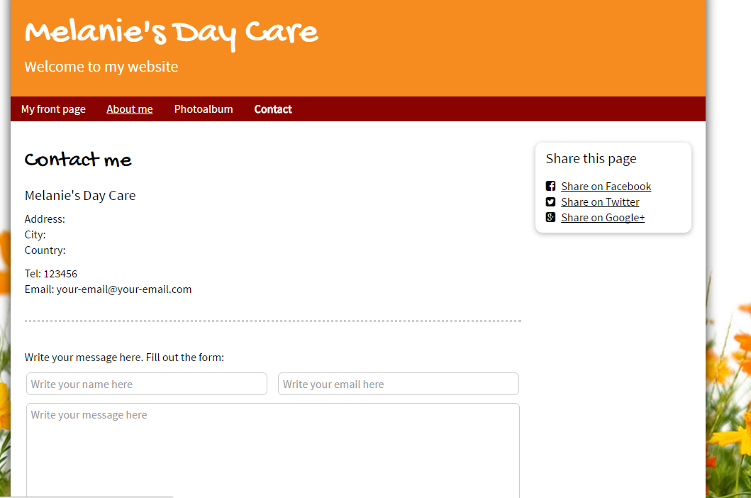

**Guidelines**

* Step 1 : Clarify requirement & scope with mentor
* Step 2 : Create prototype
* Step 3 : Design database base on created prototype
* Step 4 : Code & Test